Data Generating Process Recovery



Parameter Recovery



Posterior Model Probabilities



RaDDM Individual Estimates



RaDDM Group Estimates

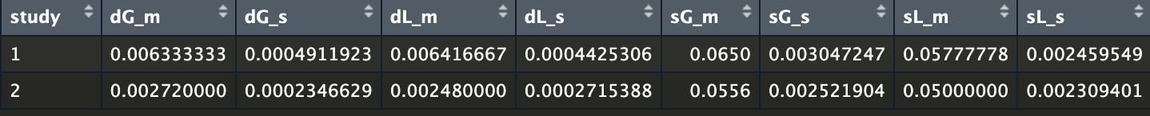

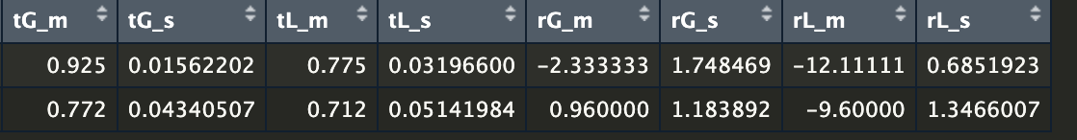

MaxMin Estimates



MaxMin Out-of-Sample Performance

